1. In GV File Upload-Order Data-File Upload-User can upload all kind of files(including tmp files) but upload message is only upload .csv files

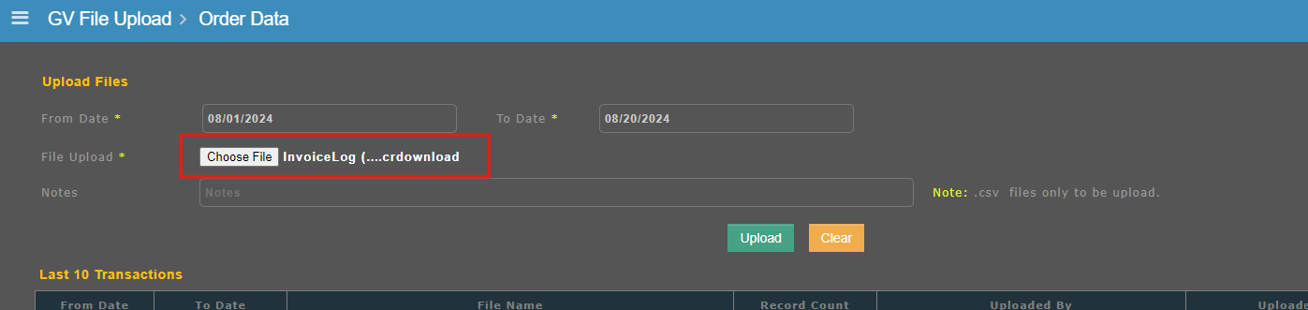

1. In GV File Upload-Leg Data-Note field text box is not present.

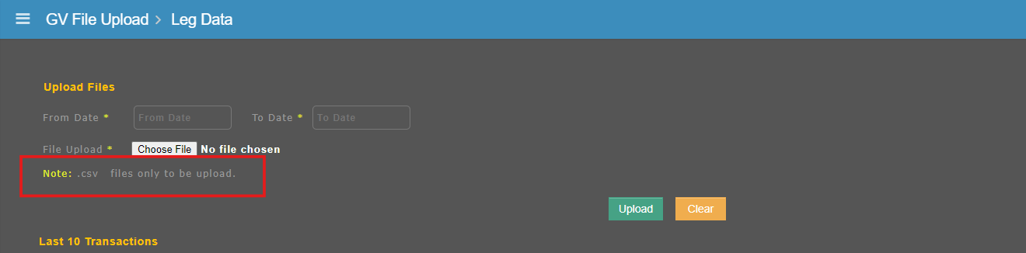

1. In GV File Upload-Crew Data-Click View Report button-After select valid from and to date and click run button, table doesnot moves to last row.
2. In GV File Upload-Mandatory alert message is not showing properly in all sub-modules.
3. NS File Upload-P/L File Upload-Manual Upload tab-Without any details and click upload button page should not display mandatory message and it shows some other pop up.

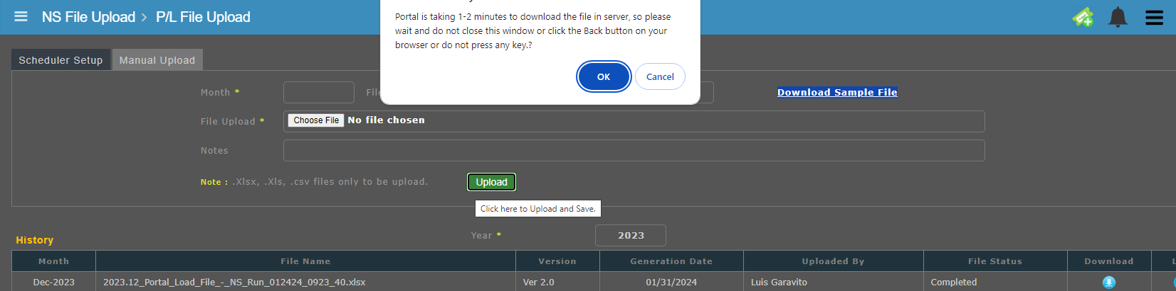

1. FOS File Upload-Trip Time-When click help button no function is happened which means button only able to click but no activity is happened in the screen

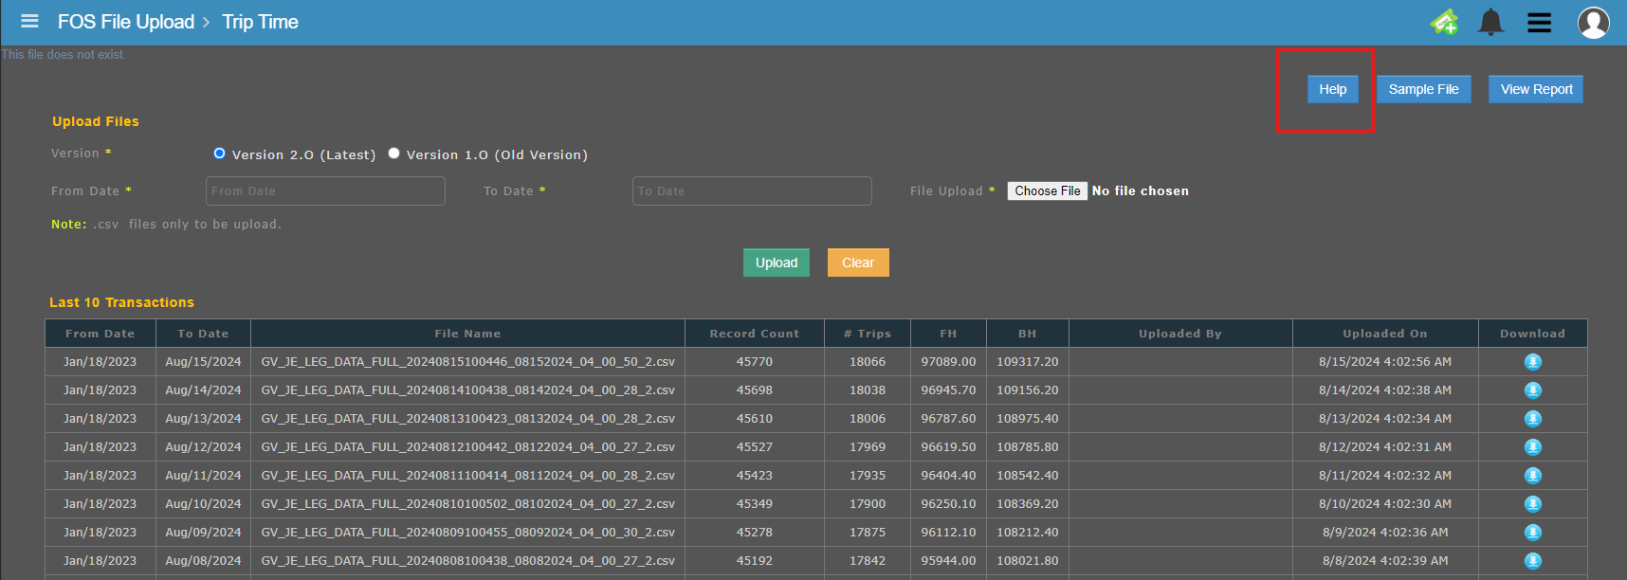

1. FOS File Upload-ZULU Report-Click hourly radio button, In start and End Time dropdown when select values details are not displayed properly from the dropdown.

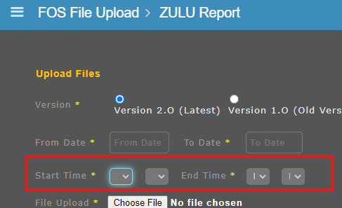

8.